Crossflow Turbine Design

# ME 5427

# Zhaoyi jIang(.1364)

# 03/04/2019

## Introduction

In this report, the design of the crossflow turbine is discussed. The crossflow turbine is low speed machine that suits a condition with low head but high flow. The cost for it is also cheap. The water flow through the turbine twice which improves the efficiency.

The students use given data and multiple data ranges to find the optimal efficiency for the crossflow turbine. Additionally, the efficiency, dimension of stator and rotor, dimension of distributor and blasé number are calculated. The report contains several pictures of design and tables of data.

## Design procedure

The Available head, Volumetric flow rate and Efficiency of inlet pipe are given in advance to start the problem. The numbers are listed below:

$$H=2.6m Q=2.45{m^{3}}/s η_{p}=0.95$$

The friction losses of inlets distributor, ϕ, is given to be 3%. For α1, the range should between 60-70 degrees. To start the design, the initial value of 70 degrees is selected. Use the following equations, the effective head, H, the inlet velocity, c1, and the runner inlet velocity, u1, can be calculated:

$H= η_{p}H_{0}=2.47m$ $c_{1}=φ\sqrt{2gH}=6.75m/s$ $u_{1}=\frac{1}{2}\sin\left(α1\right)*c_{1}=3.173m/s$

For next step, since the characteristic speed is in the range 20-50, use the following equation and make a parametric table to find the range of diameter, D1.

$$N_{c}=\frac{60u_{1}}{πD_{1}}*\frac{Q^{0.5}}{H^{0.75}}$$

The parametric table is as follow:

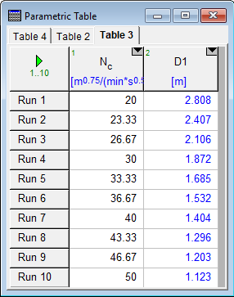

Figure 1: Table of Nc and D1

The diameter is chose to be 1.4 for convenience. The corresponding Nc is 40.11. Since D2 is two third of D1, the dimension of D2 is 0.933m. With all initial velocity and angles calculated, the first velocity triangle can be calculated using the following equations:

$c_{u1}=c_{1}*sin⁡(α1)$ $c_{r1}=c_{1}*cos⁡(α_{1})$ $w_{u1}=c_{u1}-u_{1}$

$w_{r1}=c_{r1}$ $w_{1}=\sqrt{{w_{r1}}^{2}+{w_{u1}}^{2}}$ $β_{1}=arctan⁡(\frac{w_{u1}}{w_{r1}})$

Since the friction on the blades will reduce the speed by 2% and $β_{2}$ is simply zero, the second velocity and third velocity triangles can be calculated using the following equations:

$w_{2}=w_{3}=0.98w_{1}$ $u_{2}= u_{3}=\frac{πD_{2}N}{60}$ $c_{2}=c_{3}=\sqrt{{u_{2}}^{2}+{w_{2}}^{2}}$ $α_{2}= arctan⁡(\frac{w_{2}}{u_{2}})$

The forth velocity triangle can be calculated using the following equations:

$w_{4}=0.98w_{3}$ $u_{4}=u_{1}$ $β_{4}=β_{1}$

$w_{u4}=w_{4}*sin⁡(β_{4})$ $w_{r4}=w_{4}*cos⁡(β_{4})$ $c_{u4}=w_{u4}-u_{4}$

$c_{r4}=w_{r4}$ $c_{4}=\sqrt{{c_{u4}}^{2}+{c_{r4}}^{2}}$ $α_{4}=arctan⁡(\frac{c_{u4}}{c_{r4}})$

Here is a table which summaries the velocities and angles for all locations:

|  |  |  |  |  |
| --- | --- | --- | --- | --- |
| Variables/locations | 1 | 2 | 3 | 4 |
| C(m/s) | 6.753 | 4.389 | 4.389 | 2.222 |
| u(m/s) | 3.173 | 2.115 | 2.115 | 3.173 |
| w(m/s) | 3.924 | 3.846 | 3.846 | 3.769 |
| $α$ (degrees) | 70 | 61.19 | 61.19 | 3.242 |
| $β$ (degrees) | 53.95 | 0 | 0 | 53.93 |

Since the fluid should exit the runner with minimum kinetic energy, the velocity c4 should be as small as possible. The velocity u1 should be adjusted in order to optimize the exit speed. The u1 is also dependent on angle $α_{1}$. Here is a parametric table of $α_{1}$, and We, which is the KE at exit:

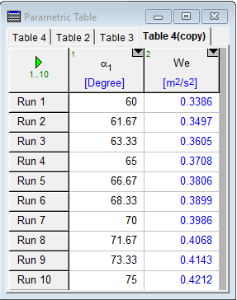

Figure 2: Minimum KE

The We is calculated using the following equation:

$$We=u_{4}*c_{4}*sin⁡(α_{4})$$

The $α_{1}$ should be selected as 60 degrees to minimum the exit kinetic energy. The corresponding velocity triangles are as follow:

|  |  |  |  |  |
| --- | --- | --- | --- | --- |
| Variables/locations | 1 | 2 | 3 | 4 |
| C(m/s) | 6.753 | 4.792 | 4.792 | 3.245 |
| u(m/s) | 2.924 | 1.949 | 1.949 | 2.924 |
| w(m/s) | 4.466 | 4.377 | 4.377 | 4.466 |
| $α$ (degrees) | 60 | 65.99 | 65.99 | 2.045 |
| $β$ (degrees) | 40.89 | 0 | 0 | 40.89 |

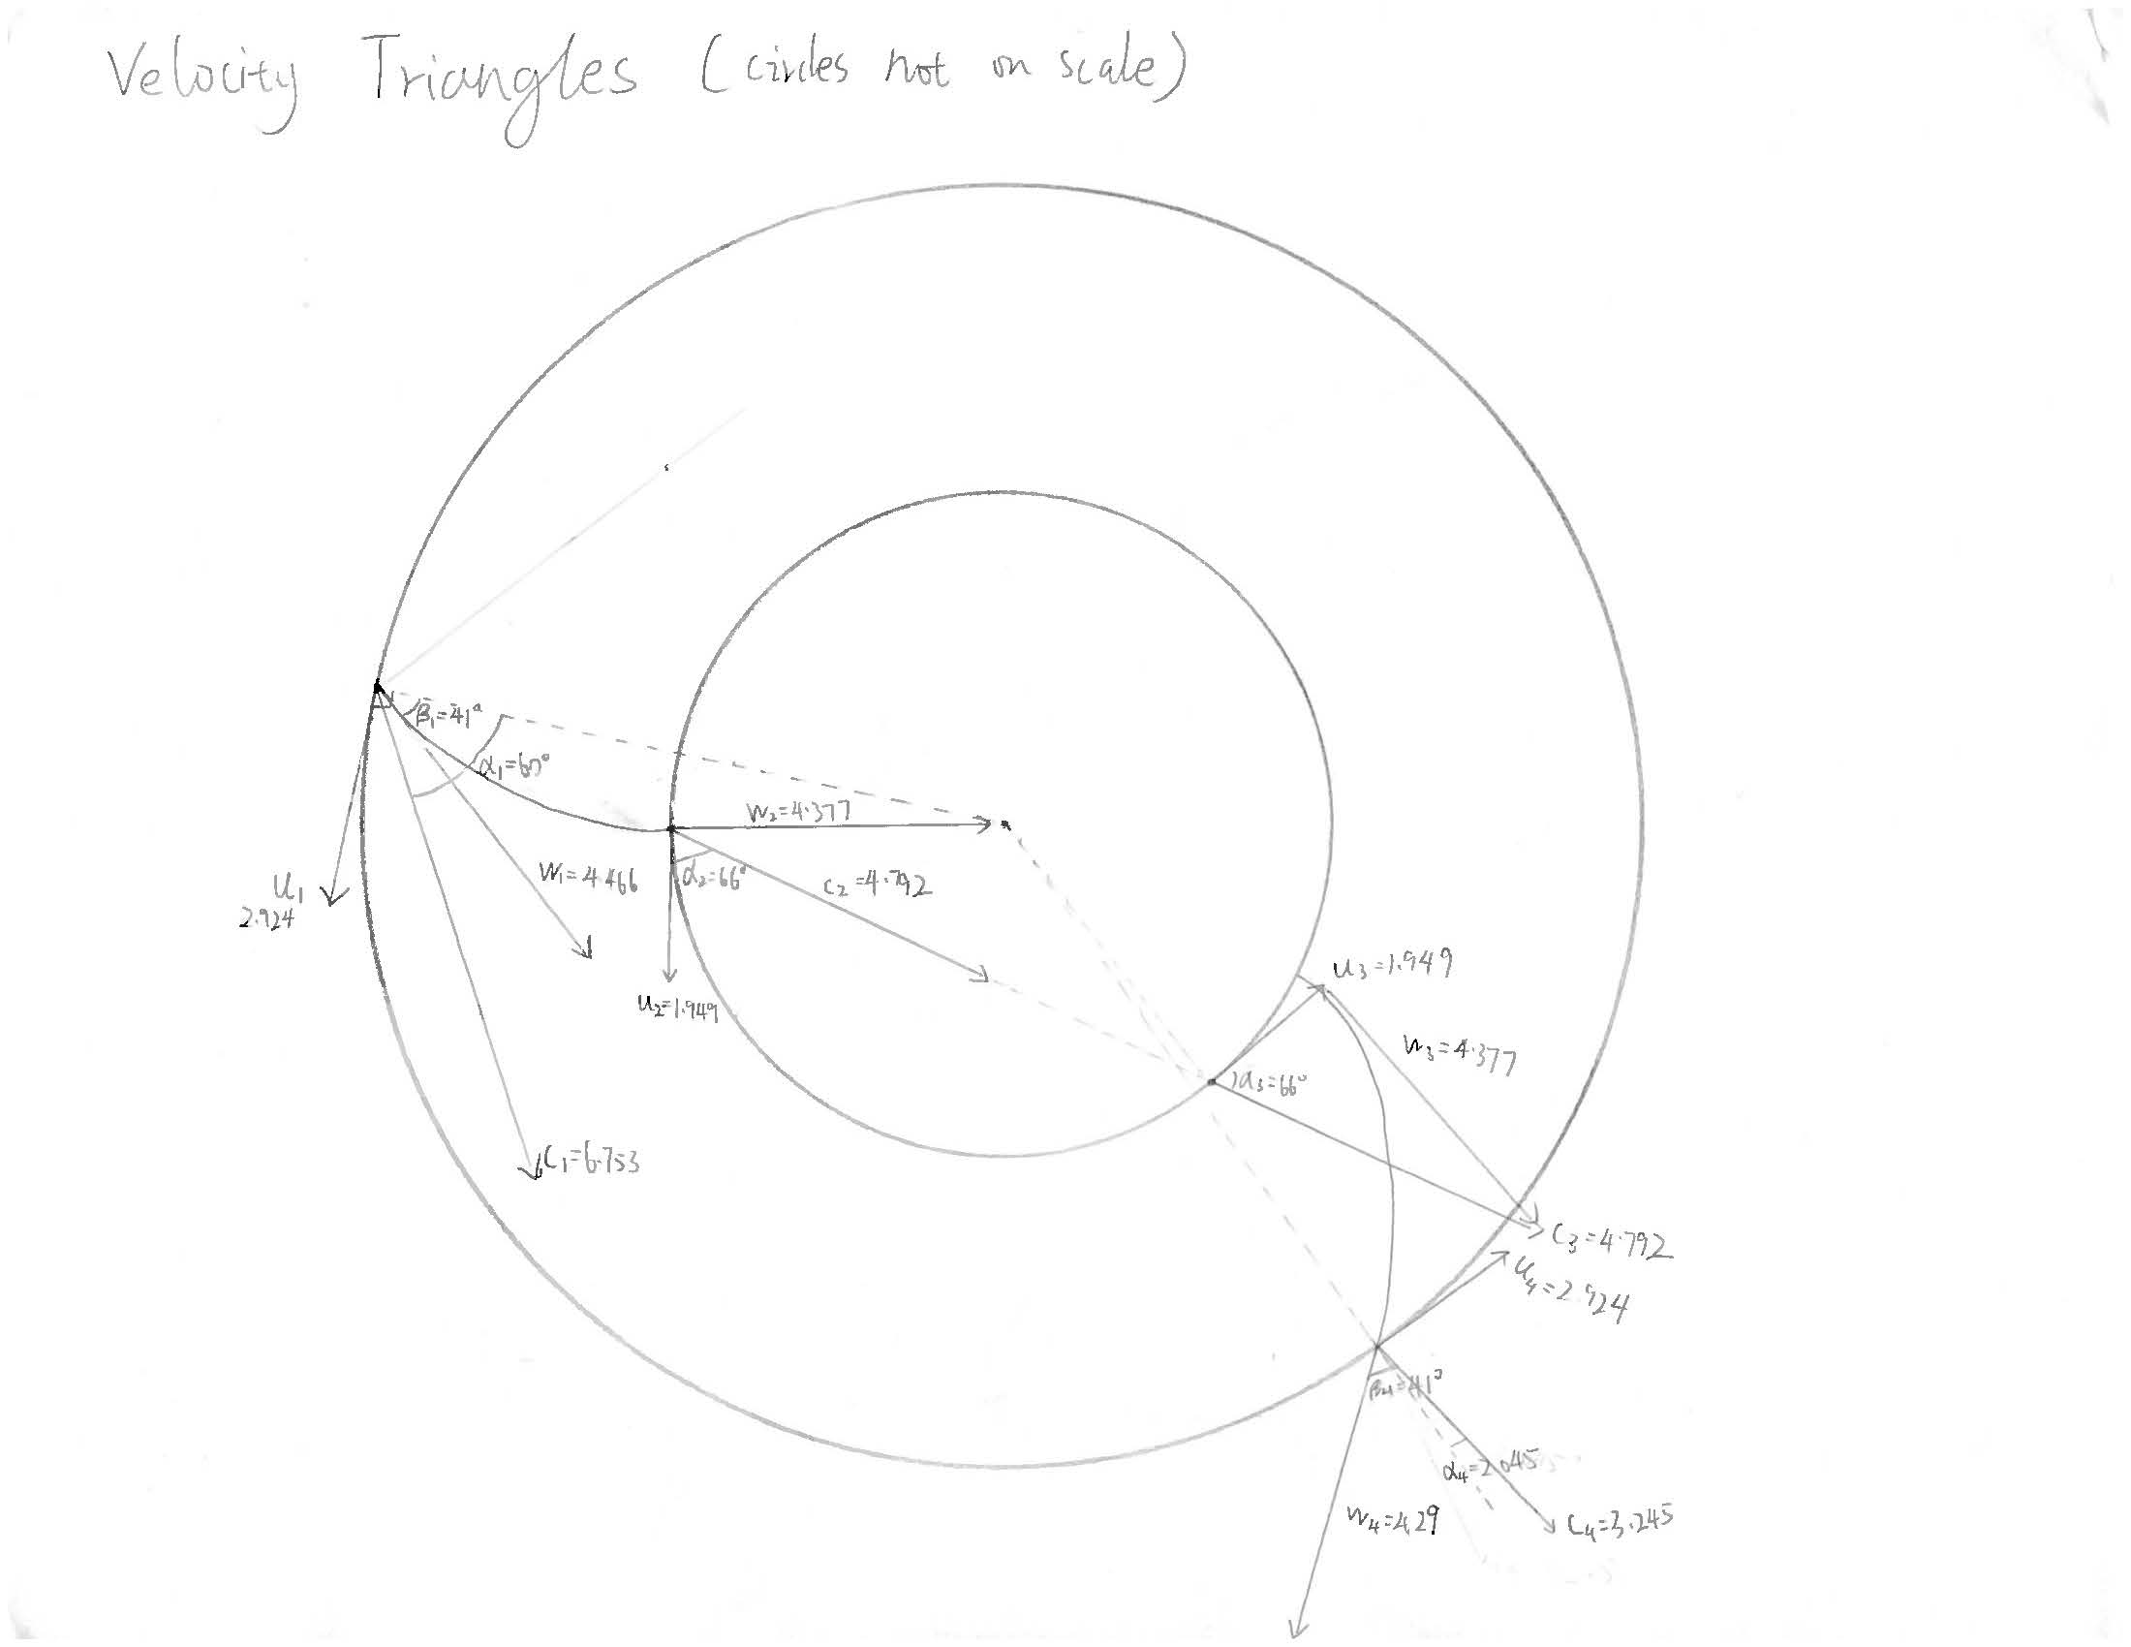

Figure 3: Velocity Triangles

Since the velocities are decided, the Power and efficiency can be calculated using the following equations:

$ẇ=ρQW=41063W$ $η_{h}=\frac{W}{gH}=0.6917$

The blade number should in between 20 and 32. The number 24 is selected and lambda is selected to be 60 degrees. Since the Q is given and the blade’s thickness is 2mm. The features listed below are calculated using the corresponding equations:

$θ=\frac{360}{z}=15 degrees$ $Q=c_{r1}*(\frac{D_{1}*π*B}{6}-\frac{z*0.002*B}{6})$ $Q=B*S_{0}*c_{1}$

Where the length of turbine B is calculated to 1.001m and height So is calculated to be 0.3625m.

The design of blade is shown in the picture below, the radius of a blade is 0.3m and the total number blade is 24.

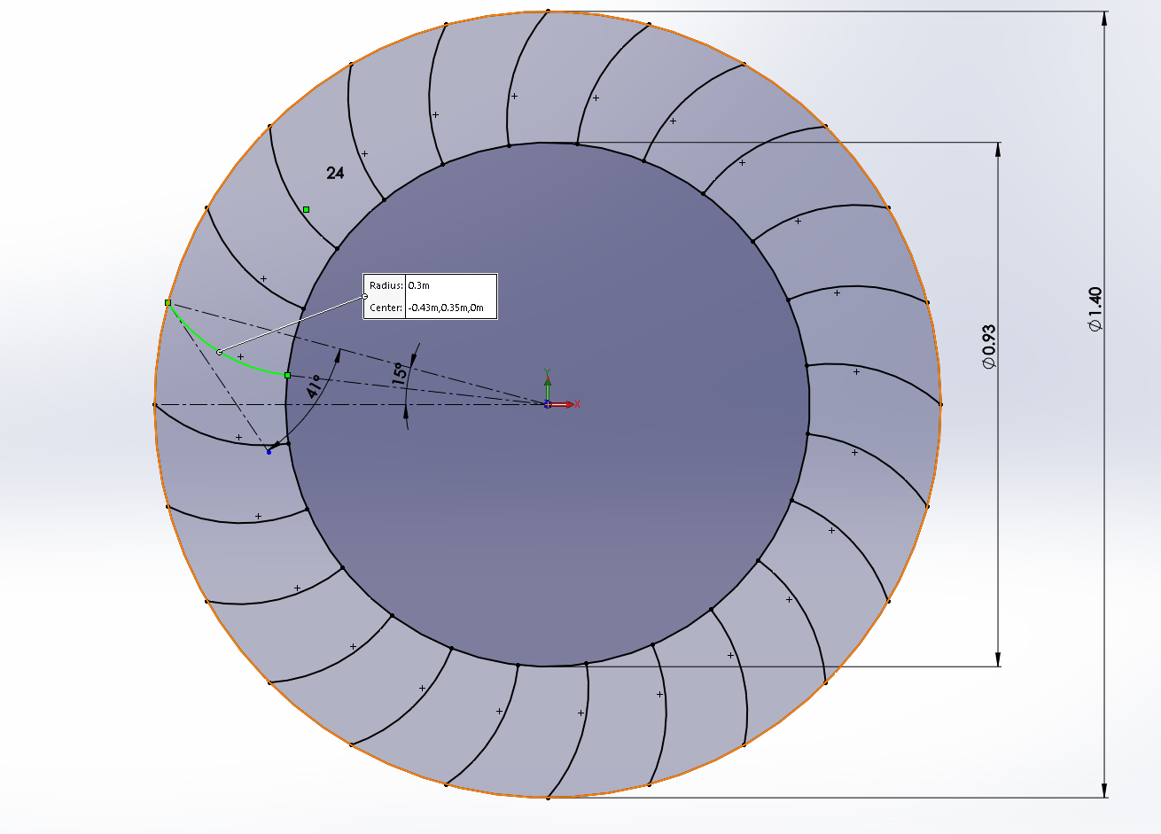

Figure 4: Blade design

The distributor design is also shown in the picture below. The lambda is selected to be 60 degrees and the radius the outer wall is 0.81m:

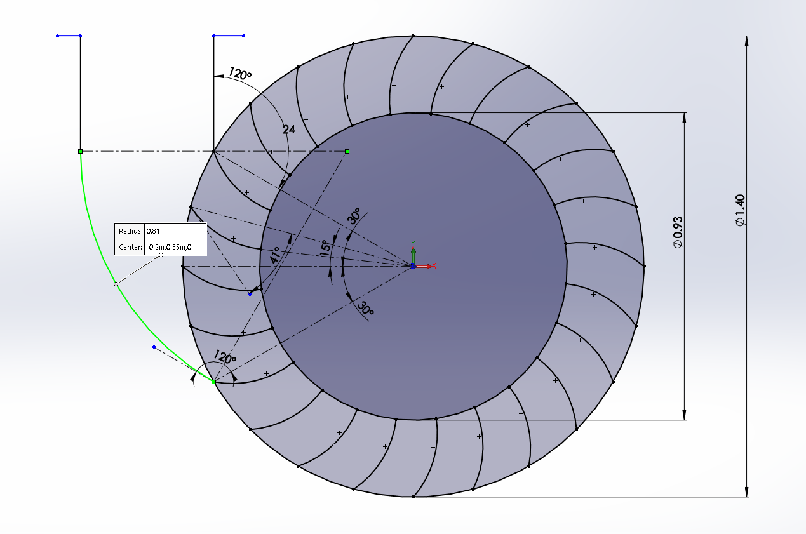

Figure 5: Distributor design

**Conclusion**

The turbine has 24 blades, the inlet degree is 60. That will ensure the kinetic energy at the exit to be minimum but that will drag down the total efficiency a little bit. The lambda of distributor is 60 degree which gives us a straight good looking distributor, as shown on the picture above.

**Appendix**

